- Using the fin template as a guide, carefully cut out three fins for your rocket from a paper or plastic file folder. Please try to conserve materials.
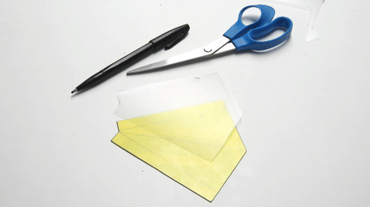
- Fold the fins along the internal lines.
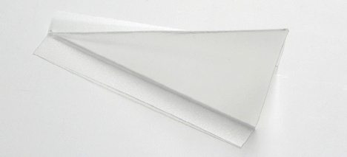
- Tape the fins to the rocket, spacing them in even thirds around the bottle. 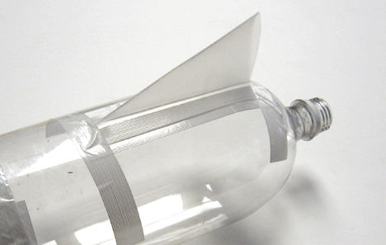
- Tape tennis ball to top of rocket.
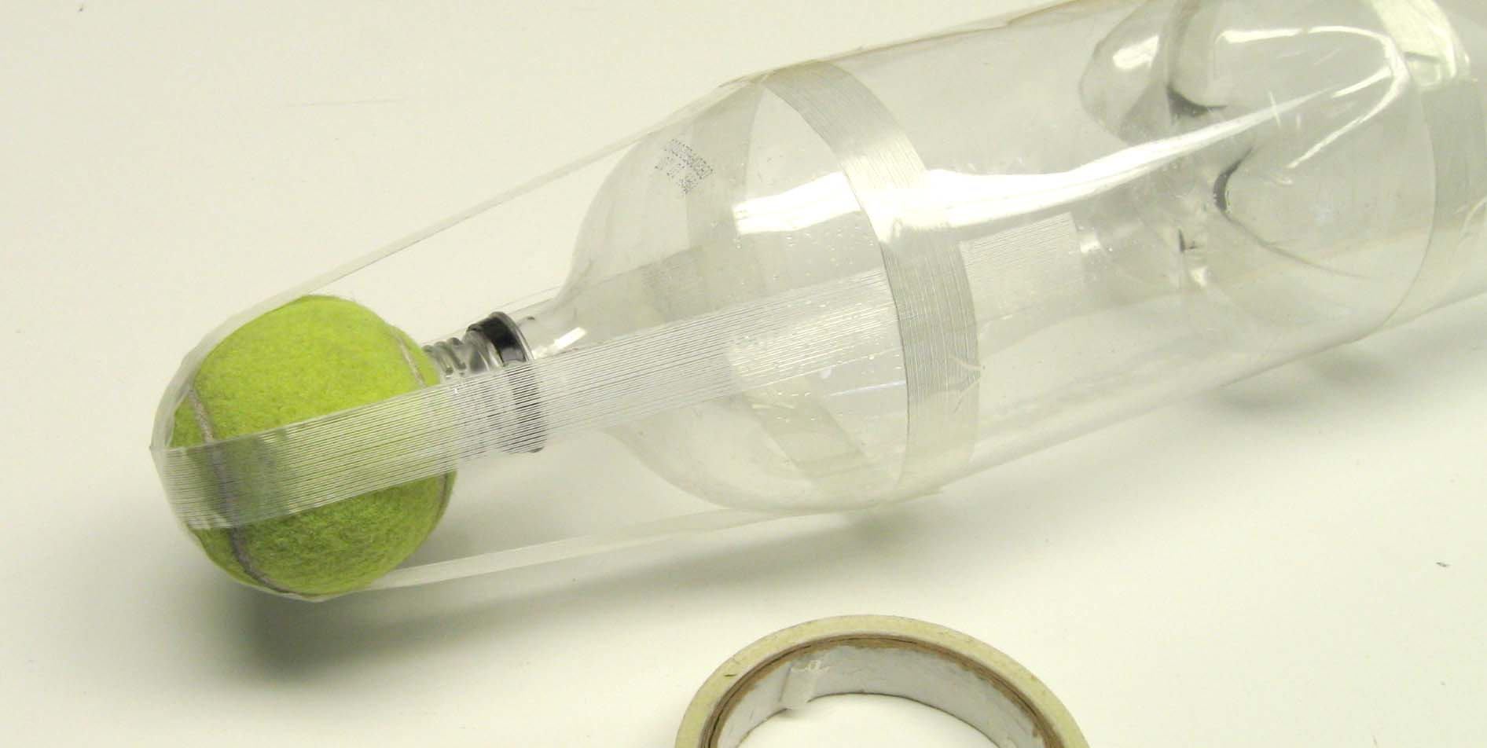

Hints for improved performance

- Make sure everything on your rocket is neat and straight.

- Place your tennis ball farther forward on your rocket to make your rocket more stable. To do this you will need to add material or a second bottle.

- Move your fins further back on your rocket to make your rocket more stable. This is difficult. Be creative.

- Make a nose cone to reduce the drag on your rocket.

